


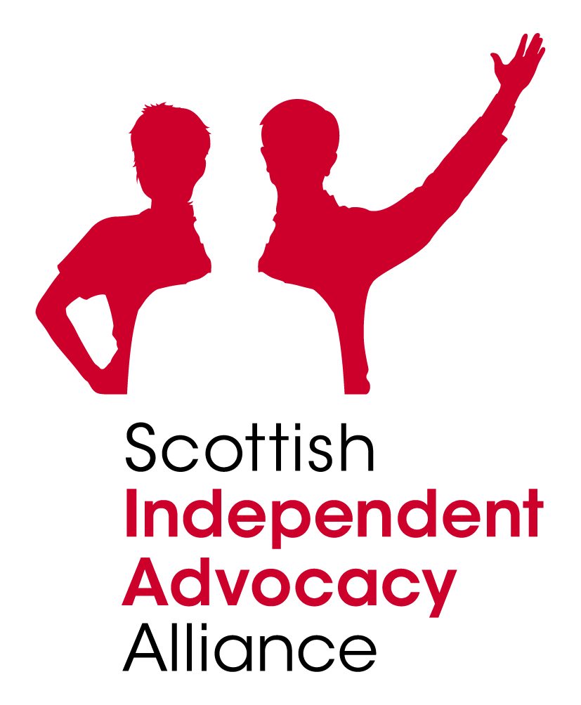
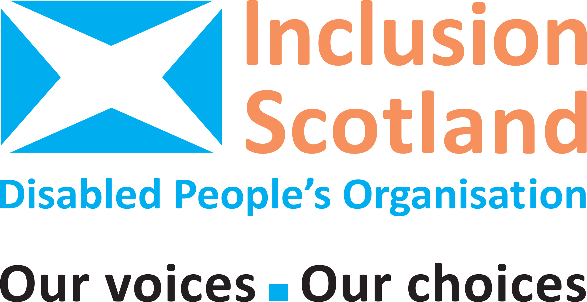

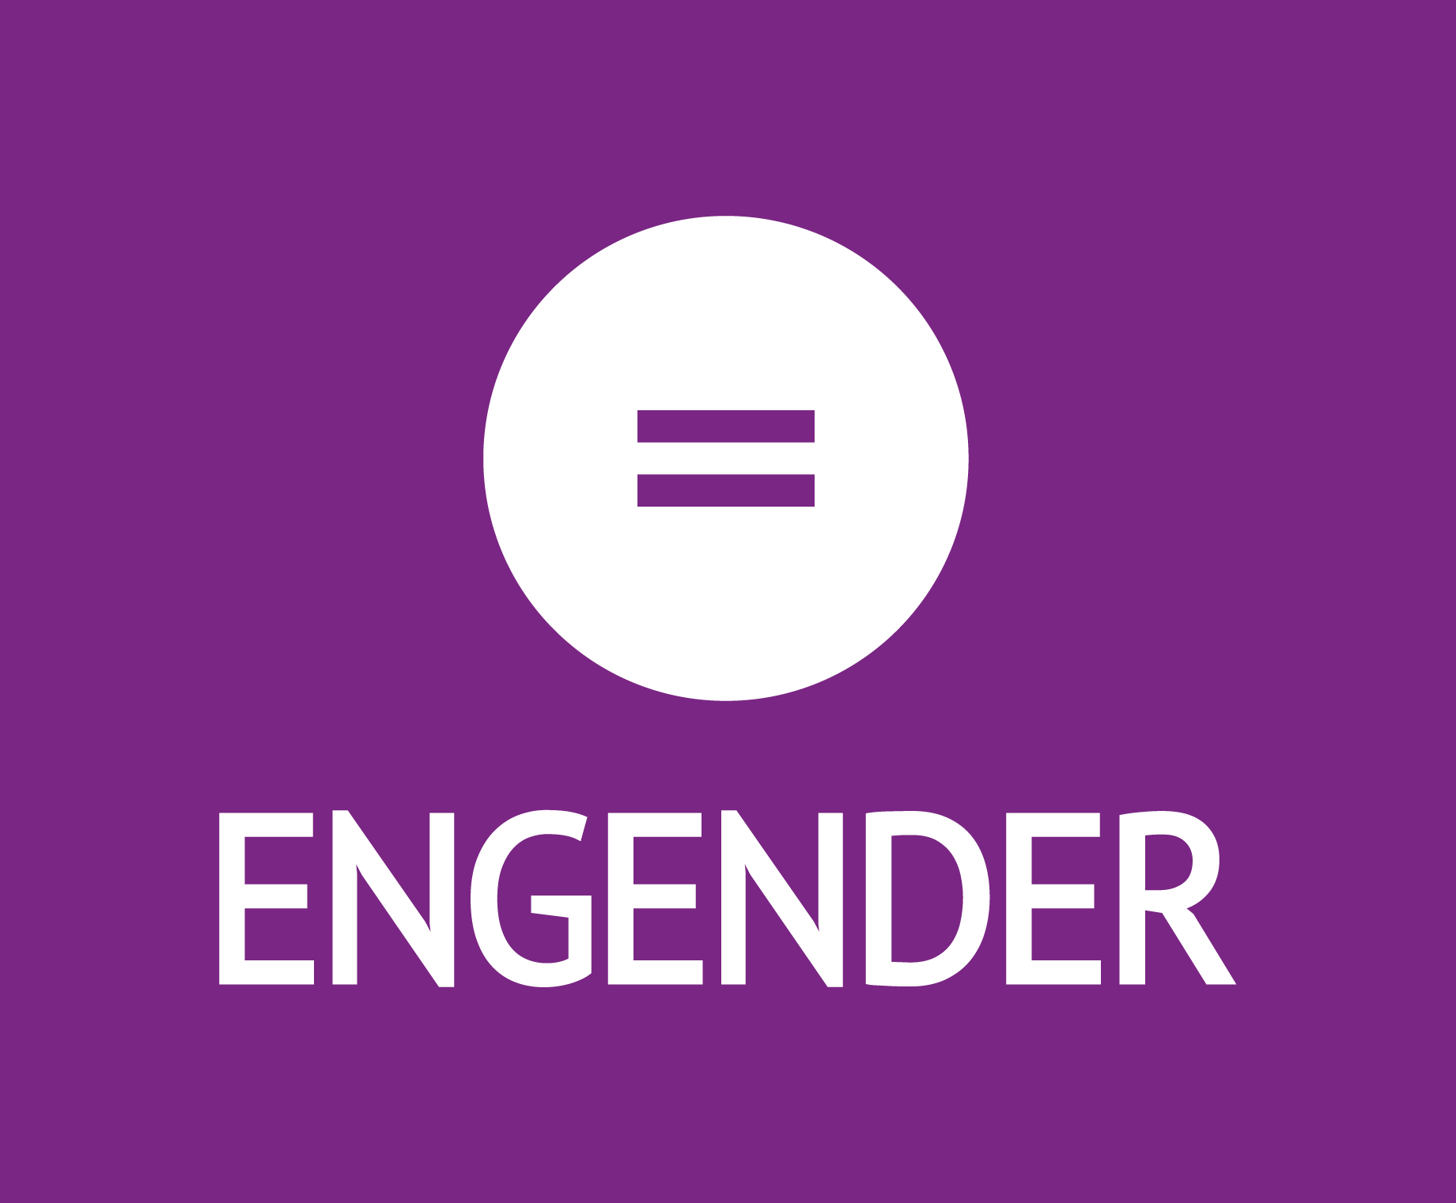

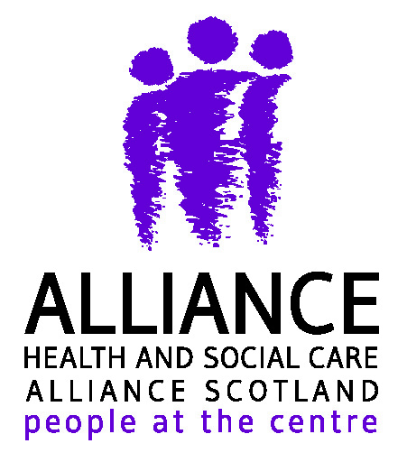
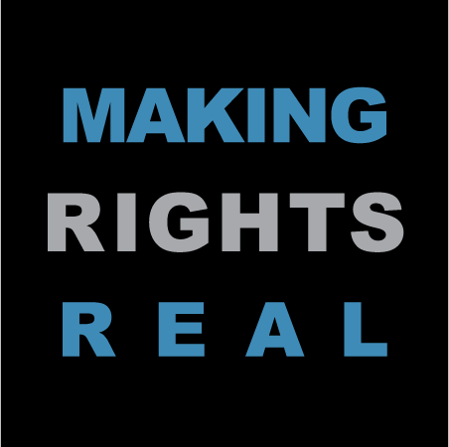
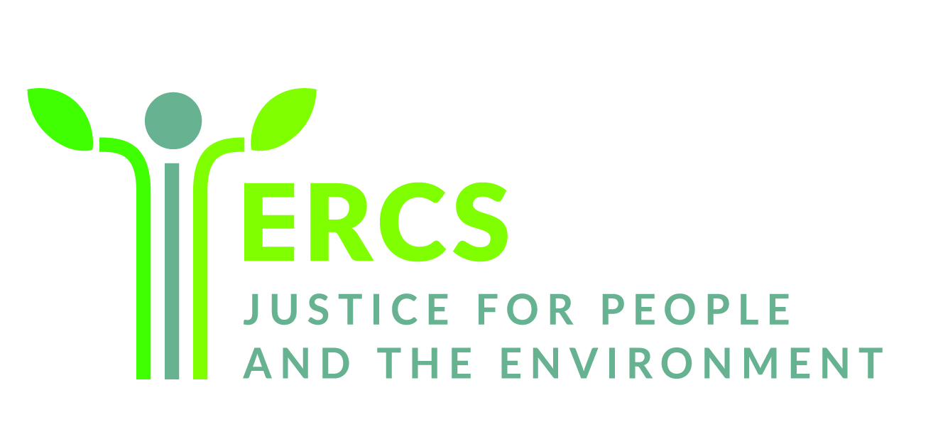
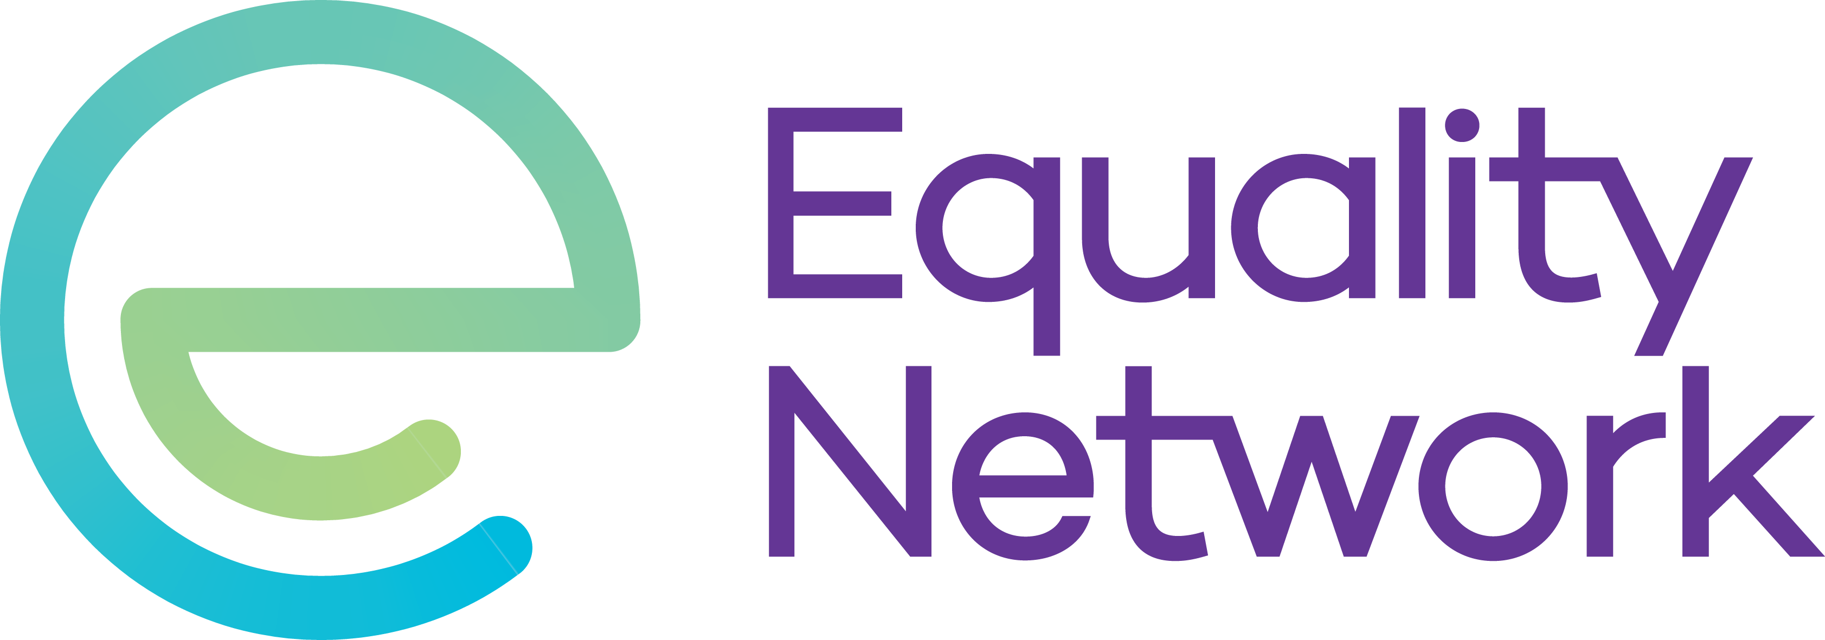
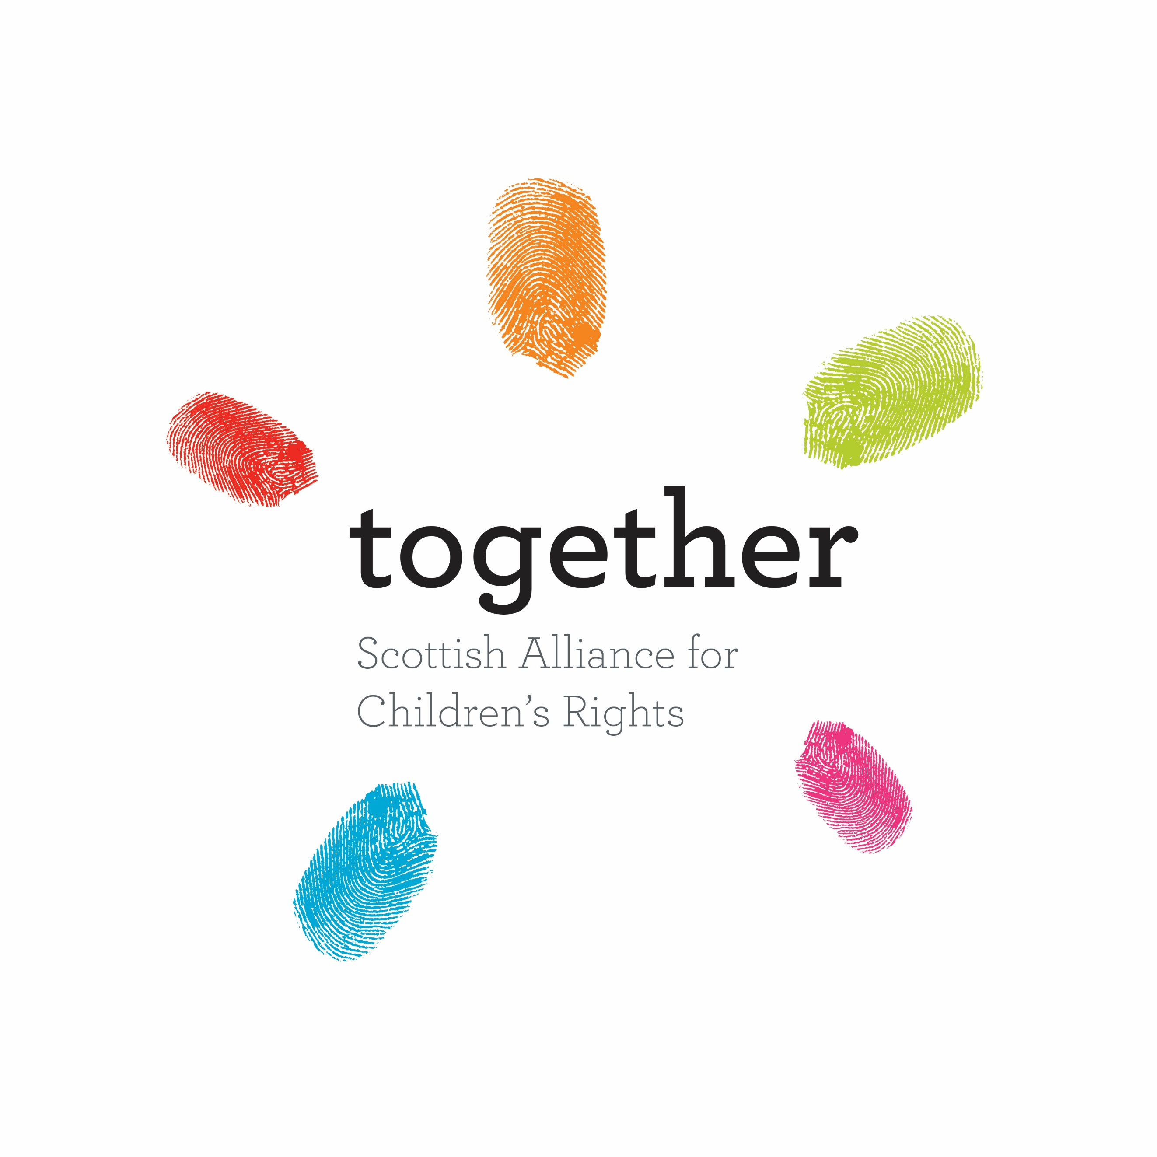
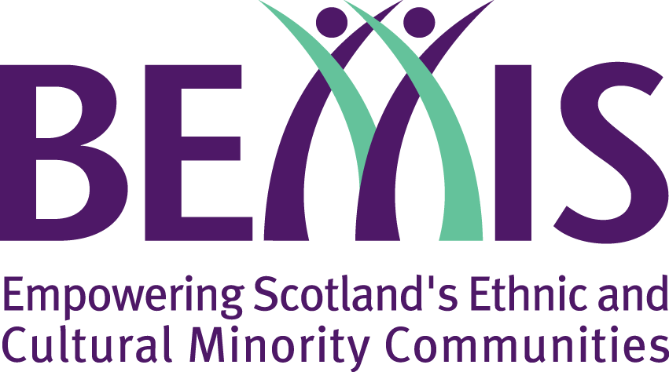



Sent by email

12 December 2022

Dear Minister for Equalities and Older People Christina McKelvie MSP

RE: Human Rights Incorporation Bill
Thank you for your response on 11 October 2022 to our joint letter regarding the delay in the public consultation on the Scottish Human Rights Incorporation Bill. We greatly welcome the reiteration of the Government’s commitment to introducing a new Human Rights Bill within the lifetime of the current parliament and that you will continue to prioritise this work.

We recognise that some of the content of both letters has been subsequently discussed at the Advisory Board, of which several of our organisations are members. We welcome the increasingly open and thoughtful approach taken by officials to discussion about details of the Bill, and we consider that this will ultimately lead to a stronger and more effective Bill. This reply in writing is to seek clarification of some of the content of the letter of 11 October 2022, and to highlight some of our key, ongoing concerns.

Resource
We welcome the increased staffing in the Bill team, as conveyed to the Advisory Board on 23 November 2022. As mentioned during a meeting, an organogram of those in the Directorate for Equality, Inclusion and Human Rights would be useful for enabling engagement. We want to emphasise again, that this Bill is ambitious and very complex, and if it is to be world-leading and therefore breaking new ground, it needs to be resourced accordingly. The Bill team needs to have all of the capacity and expertise it requires. We welcome capacity assessment and ongoing updates through the Advisory Board on the resource being prioritised for this Bill.

Implementation
We welcome the statement in your letter that ‘Our hope is that – by focussing on implementation at this early juncture in the legislative journey – it will create the necessary paradigm shift to foster increased human rights realisation in Scottish public life.’ We agree that a paradigm shift – indeed, a culture and power shift - will be required if this new legislation is to see rights realised for more people and communities in Scotland. With this in mind, we are concerned that the steps outlined in your letter to convene a subgroup of the Executive Board is too limited an action towards implementation at this stage.
We understand that there is further thinking going into planning for implementation, including potential discussion at the Advisory Board. We emphasise a few particular concerns at this stage:
- The content of our international human rights is already very clear, and there is already a duty on Scottish Ministers to observe and implement them. Therefore, there should be no sense of waiting for the Bill to establish what needs done or for public authorities to start to take a human rights-based approach. So much of what is required – especially if this law is to be implemented fully and not only with narrow compliance – can start to take effect now. Furthermore, public authorities already have a duty to comply with the ECHR within the Human Rights Act 1998 but we know that, whilst this has had positive effect, there is much more that public authorities could do to embed this duty into practice. For example, a Consortium survey found that there was very little consideration of human rights at all during COVID-19 policy and service changes. We seek clarification of the discussions and engagement that the Government is having with public authorities about implementation needing to begin now.
- The task of implementation is too big for the Bill Team alone who need all of their capacity, and more, to develop the content of the Bill and accompanying guidance. Instead, beginning implementation requires dedicated resource within Government and within public authorities. This includes building up the expertise of officials to understand, design and deliver implementation in partnership with rights-holders, civil society and public authorities. Whilst our organisations, and many others across civil society, will gladly play our role in helping to enable implementation, it is important that the Government does not rely solely on our sector as a means of implementation. Instead, the expertise, capacity and resources must be steadily built up within the Government from this point on.
- We note the ‘Progressing the Human Rights of Children in Scotland: An Action Plan 2021 – 2024’ and welcome this as an outline of practical positive steps towards UNCRC implementation. We ask that the Scottish Government does the same for the wider incorporation Bill, namely to develop an action plan for implementation which will begin in 2023. We highlight that this will also be an appropriate response to one of the key messages from the Lived Experience Boards - that of concern, and some scepticism combined with a lack of trust, that this Bill will lead to significant change. Board members very much want to see this Bill passed but they are very concerned that energy and attention will be given to getting the Bill passed and onto the statute book, and not on the law having an impact. Deliberately building in and planning for impact of the Bill now, and publishing this for transparency and accountability, would be an important step towards full implementation.
- We do not believe that implementation of the legislation should be left to duty bearers. Implementation should include Government, public authorities, civil society and rights holders. Only with all of these voices shaping and driving implementation will it bring the culture shift required. We seek assurance that this is the approach that will be taken to plans for implementation.

Timescale
We emphasise again, that with the delayed consultation timetable comes a risk of increased disengagement from wider civil society and rights holders. We therefore welcome clarification and publicising of a definite timetable for the consultation. We flag too, that having a definite timescale would allow our organisations, and many more across civil society, to plan in engagement with our members and networks to respond to the consultation.
Lastly, we remain concerned that amendments to the UNCRC Incorporation Bill have still not been considered by the Scottish Parliament, and we ask for your assurance that progressing this is being prioritised by the Scottish Government. Alongside this, we are concerned that other legislation such as plans for a Learning Disability, Autism and Neurodiversity Bill may be regrettably delayed and seek clarification on progress with this Bill also.
We once again assure you that we will do all that we can to see this new, enhanced human rights framework delivered and implemented fully to make human rights for all a reality in Scotland.
We look forward to hearing from you.

Yours sincerely,

Naomi McAuliffe, Amnesty International
Pete Ritchie, Nourish Scotland
Emma Hutton, JustRight Scotland
Charlie McMillan, Scottish Commission for People with Learning Disabilities
Cat Murphy, Engender
Juliet Harris, Together (Scottish Alliance for Children’s Rights)
Danny Boyle, BEMIS
Clare MacGillivray, Making Rights Real
Sara Redmond, Health and Social Care Alliance Scotland (the ALLIANCE)
Suzanne Swinton, Scottish Independent Advocacy Alliance
Tim Hopkins, Equality Network
Scottish Environment LINK – Governance Group
Leo Starrs-Cunningham, Convenor - Inclusion Scotland
Alison Watson, Shelter Scotland
Shivali Fifield, Environmental Rights Centre for Scotland
Mhairi Snowden, Human Rights Consortium Scotland

