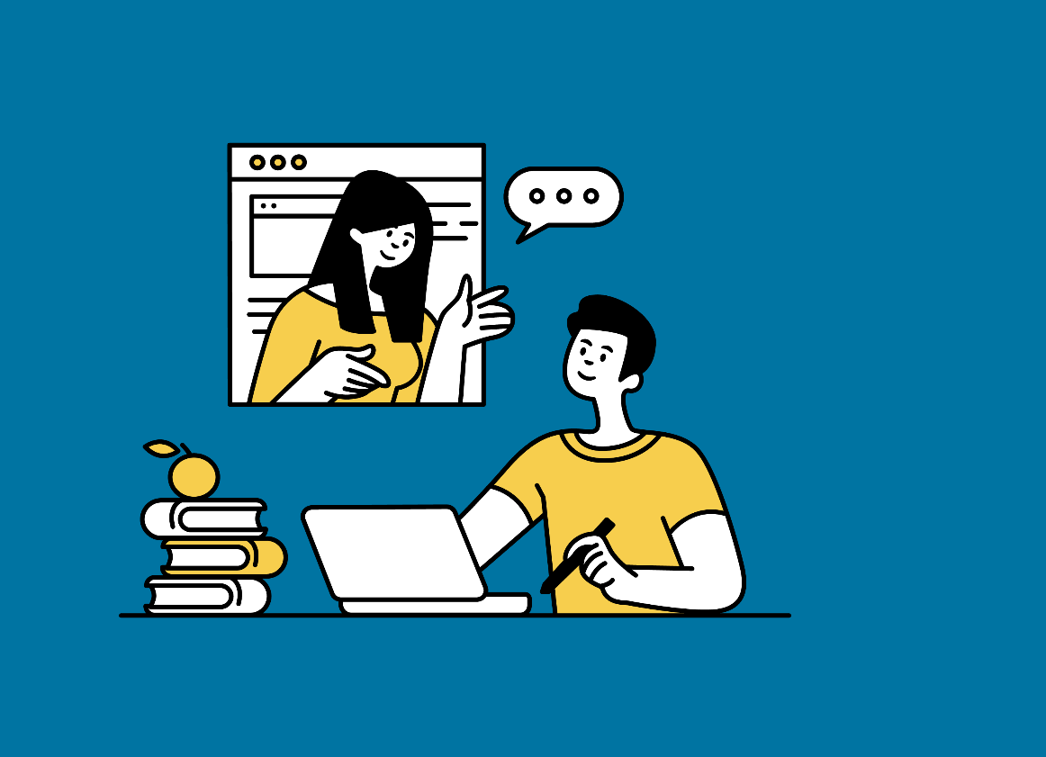 | “Our Stories, Our Rights”  Guidance on how to  write your own story

Writing a story, even if it’s yours can be challenging! Believe us...we know!
We have created this template to help you express yourself and write about your experience.
This series of tips and questions can be used as guidelines to help you create your storyline.

- Think about how the Human Rights Act has made a difference in your life, or for someone else close to you, or who you have helped.
- What was the problem you faced? Why was it hard to find a solution?

- What did you do next? Did you use human rights to talk to a decision maker? Did you write a letter? Did you speak to an advocacy worker or a lawyer?

- How did using the Human Rights Act make a difference? What was the outcome?

- What advice do you have for someone else who might want to use the Human Rights Act but not know where to start?

If English is not your first language and you would like to submit your story in another language, we may be able to translate it for you.
Please contact us via email jrfa@justrightscotland.org.uk and let us know.

You can share your story with us by sending your file via email to jrfa@justrightscotland.org.uk.
It can be a word document with photos or pictures or a video.

