PRESS RELEASE
Survivor Engagement: Assisting Integration in Human Trafficking
15th December 2020
Today, JustRight Scotland (JRS) held an online event to share the results of a 2-year EU AMIF funded project which has focused on the long-term integration of trafficked women recovering from sexual exploitation as well as empowering survivors of human trafficking to play a leadership and mentoring role in our responses to human trafficking at an operational as well as strategic and policy level in Scotland.
Through the ASSIST Project, JustRight Scotland (JRS) has been able to provide free weekly legal surgeries for female survivors of trafficking for sexual exploitation at the offices of the Trafficking Awareness Raising Alliance (TARA) as well as providing free, holistic, gender-specific, specialist and trauma informed legal representation on legal issues related to a woman’s integration needs in areas such as citizenship, identification issues, family reunion and compensation.
The ASSIST project has also allowed us to bring together a group of inspiring women with lived experience to develop and deliver a Peer Support framework for female survivors of sexual exploitation as well as to make important contributions to policy consultations in Scotland including the review of Scotland’s Human Trafficking Strategy.

Integration Best Practice
At the event, JRS and key partners discussed the importance of focusing on medium to long term outcomes for those identified as victims of human trafficking in Scotland.
JRS launched a report on best practice principles in relation to the integration of women affected by human trafficking for sexual exploitation and the full report and its summary can be found on our website.

Lived Experience
Women with lived experience also shared their views on the importance of survivor involvement through a pre-prepared video.
A participant in the project said:-
It’s really, really, important to be heard. They are only sitting there in suits, drafting strategies and writing reports. They are only writing it from what they’ve read, not from what they’ve seen and not from what they’ve been through. If our voices are heard, if we sit with the government and tell them this is what we’ve been through, this is how it’s been done and these are the tricks these people are using, I think it will make a lot of difference. But coming from their perspective, they’ve never been there, they’ve not walked in our shoes. They are only sitting there and reading what they’ve read. They don’t have the lived experience of what trafficking is. We’ve been there, we’ve walked in these shoes. We know how difficult it is, how terrible it is.
A leaflet was also launched to assist integration. This has been co-produced by women impacted by human trafficking for individuals who have just been identified as victims of human trafficking in order to assist their integration in Scotland. This can be found in multiple languages on our website here.
Partners at the event discussed the importance of ensuring lived expert experience is taken into account in our Anti-Trafficking responses. Kirsty Thomson, Director, JustRight Scotland said
This project has shown the strength of women who have survived human trafficking and who have committed to assist others who have just left a situation of exploitation or indeed are still in one. Their dedication, courage and energy has been extraordinary. For our part, we have made a commitment to securing funding to continue the important peer support work from the ASSIST Project as well as to ensure that the experience and voices of survivors shape our future responses to human trafficking in Scotland.
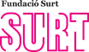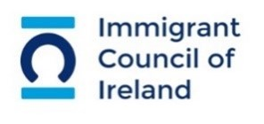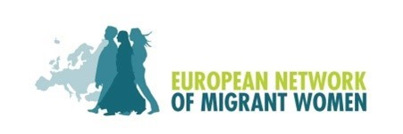

Notes to editors
About the EU ASSIST Project
The ASSIST Project, funded by the European Union’s Asylum, Migration and Integration Fund, is a two-year project led by the Immigrant Council of Ireland (ICI), in partnership with the organisations from Germany (SOLWODI), Italy(BeFree), Spain(SURT) and the UK(JustRight Scotland), as well as the European Network of Migrant Women (ENoMW). It responds to priority 5 of the AMIF call, concerning the Integration of victims of trafficking in human beings.
This initiative takes into account the gender dimension of trafficking in Europe and the gender specific harms and trauma associated with trafficking for sexual exploitation.
One of the aims of the EU ASSIST project is to provide a number of trafficked women with legal advice, information and support in accessing material assistance (social and financial). It is acknowledged in such cases, individuals often experience a significant trauma and lack the life skills, training or experience required to quickly integrate into the job market and thus provide for them or any dependents.
Press contact
Kirsty Thomson, kirsty@justrightscotland.org.uk and 0141 406 5352

